TITLE<20 point>
Full Name of Author^{1*}, Full Name of Author² and Full Name of Author³ <11 point>
¹Address (e.g., Quest International University, Perak, Malaysia)
²Address (e.g., XXX, Malaysia)
³Address (e.g. YYY, Malaysia)
*Corresponding author: please fill in the corresponding author's email address, e.g., xxx@qiu.edu.my

Abstract: This article gives you important guidelines for the preparation of a research paper for publication in Research Publish Journals. Basic information regarding Paper Margin, Font Face, Font Size, Table, Graphs, Figure etc. are described in this Template. The abstract is between 250 and 300 words and cannot have references in it. Abstract gives the idea of research process, and its significance in brief. This document gives you layout for preparation of Manuscript (inclusive of this abstract) and can be used as template. <10 point>

Keyword: The author gives 5 keywords which are related to the major part of their research work. <10 point>

INTRODUCTION
<11 point, Bold>

The introduction of paper contains the nature of research work, purpose of work, and the contribution of this paper. It contains the references of the previous work done. This template is in Word document, provides authors with most of the formatting specifications required by the author for preparation of their research paper. <11 point>

LITERATURE REVIEW
METHODS
FINDINGS
<11 point, Bold>

Page Layout and Font Used <11 point, Bold, Italic>

Authors are advised to prepare their Manuscript in separate A4 size document and cut or copy their research paper and paste it in this template. Other option is use this Template for writing their research work. All the research work of authors is only accepted in ENGLISH language and Font face is TIMES NEW ROMAN only. Major font and paragraph specifications are given in TABLE I. Number style used may be Number or Roman Numerals depends on author way of writing Manuscript. Heading and Subheading of the section is written as “I. INTRODUCTION” or “1. Introduction”, it may be Uppercase or Sentence case. Try to keep Manuscript precise and not more than 5 to 8 pages. All the body text is justified (not heading and sub heading). Major details of paper layout are given in Table 2.

Table 1
Font And Paragraph Specifications <11 point>
Fonts: Times New Roman | Font Size | Text | Align
Title of Paper | 24 | Bold | Centre
Author’s Name | 14 | Normal | Centre
Author Affiliation | 10 | Normal | Centre
Abstract And Keywords | 10 | Bold | Justify
Headings | 11 | Bold | Centre
Sub Headings | 10 | Bold or/and Italic | Left/Centre

Table 2
Paper Layout <11 point>
Header | 1.2 cm
Footer | 1.2 cm
Line Spacing for Body Text | 1.5 cm
Top Margins of Paper | 2 cm
Bottom Margins of Paper | 1.6 cm
Left Margins of Paper | 2.1 cm
Right Margins of Paper | 1.6 cm

Figures and Graphs
Figure 1
Path Analysis Model of Associations Between ASMC and Body-Related Constructs <11 point>

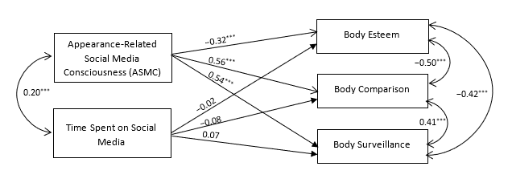

Figures, graphs and tables should be inside the margins of page. Figure caption is placed below the figures and written as Fig. 1. Similarly, Table caption is placed above the Tables and written as TABLE I. Do not use to put figure inside the border. Figures, Graph and Tables captions are flush centre and labels should be legible, 8 to 9 point. Fig. 1, is used for referring figure in the text body. Similarly, Tables and Graphs are used for referring table and graph in the text body. First figure starts from Fig. 1 and last figure ends with Fig. N (N is last figure of research paper).

CONCLUSION <11 point, Bold>

This paper shows the basic format of research paper preparation and can be used as template writing research paper. Conclusion of research paper is between 150 to 350 words. Conclusion section contains advantages, disadvantages, review the main part of research paper and use of research work.

NOTES (IF ANY) <11 point, Bold>

ACKNOWLEDGEMENTS <11 point, Bold>
Appendix section (if required) appears before acknowledgement section.

DISCLOSURE STATEMENT <11 point, Bold>
As in for potential conflict of interest reported by authors

ORCID <11 point, Bold>
Kalei Joethi Sahadevan ID: https://orcid.org/0009-0000-3744-0091
REFERENCES <11 point, Bold>
References are important part of research paper therefore each citation must be right and complete. Authors are requested to use APA Style 7th Edition. <11 point>

